|  |  |  |  |  |
| --- | --- | --- | --- | --- |
| SMRTTECH 4ID3  IoT Devices and Networks | | Node-Red Surveillance Camera and Movement Detection | | |
|  |  |
|  |  |
| March 26, 2022 | |
| Mingcheng He  400171594  hem26@mcmaster.ca  Jimmy Bu  400181756  buy@mcmaster.ca  C01  Instructor: Marjan Alavi | | |  | Table of Contents  Node-Red Surveillance Camera and Movement Detection 1  Title of Challenge 2  Community Partner 2  Technology Keywords 2  Faculty Lead 2  Description of Challenge 2  Proposed Methodology to Address the Challenge 2  Expected Deliverables 3  Risk 4 |

# Title of Challenge

Node-Red Surveillance Camera and Movement Detection

# Community Partner

None

# Technology Keywords

Raspberry Pi, Camera, Pantilthat, Node Red, Motion Detection, Python, Email

# Faculty Lead

Marjan Alavi

# Description of Challenge

Proposing a low-cost, cross-platform surveillance camera based on Raspberry Pi and Node Red.

Modern day surveillance cameras equipped with smart features like motion detection are usually expensive and difficult to setup. In this project, a Raspberry Pi with servo motor and camera is configured to function like a surveillance camera. This camera prototype is a simple, accessible, and cheap solution that enables the smart monitoring capability of a project. Its development process can familiarize students to smart monitoring and the result can be incorporated into their future smart projects.

# Proposed Methodology to Address the Challenge

Two servo motors and a camera are connected to Raspberry Pi. The video feed is streamed to Node Red by Raspberry Pi and should be accessible from any device with a browser connected to the same Wi-Fi. The user may also change the direction of the camera by interacting with the dashboard.

When the camera:

* Is pointed to a different direction because someone interacted with the dashboard, or
* Detects movement of people

An alert email is sent to a user designated email address.

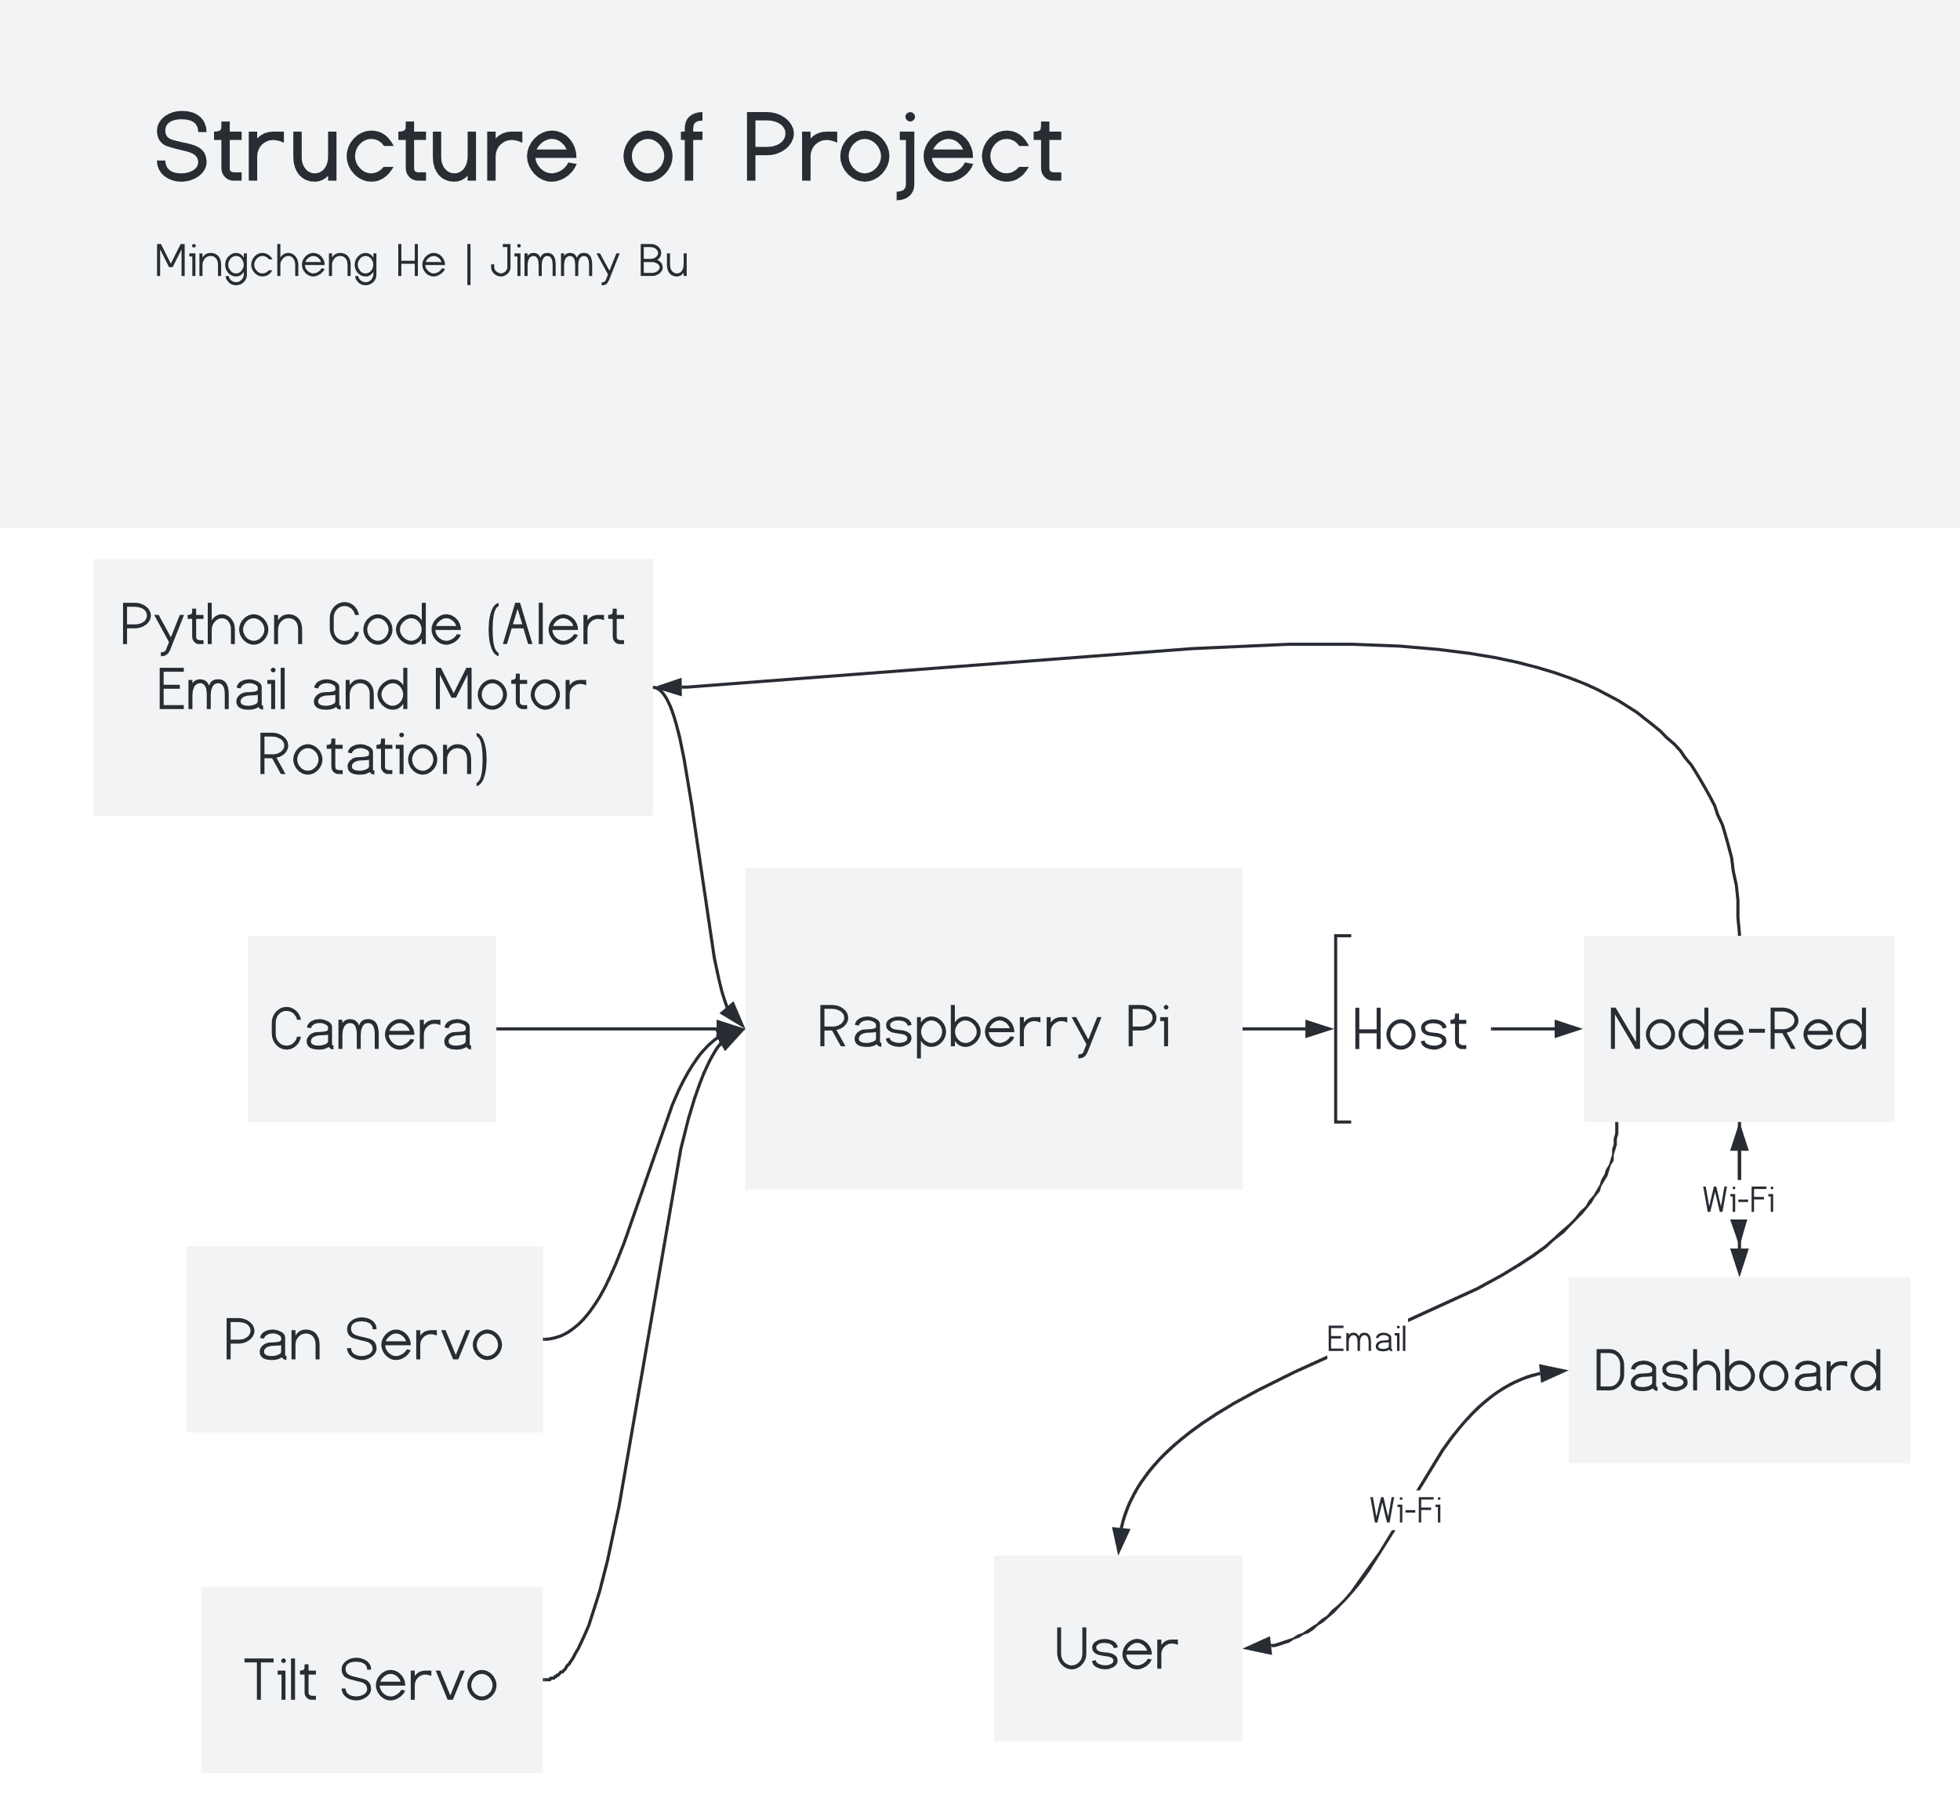

# Expected Deliverables

A Raspberry Pi, properly installed servo motors and cameras, configured Node Red nodes, and functional Python code that perform the forementioned functions are expected, along with the details of designs, progress, and results.

Students are expected to:

* Follow the instructions given and contribute significant effort
* Document their progress and effort
* Be able to explain at least part of the code
* Budget and build the prototype
* Make modification to the design that reflect their own thinking and understanding

# Risk

* While the project does not really require in-person labs, it would be beneficial if the students collaborate fact-to-face. Students must wear protection as required by the health guidelines.
* In case there is another COVID-19 spike, the scope and deliverable of this project may be changed accordingly.